# **Practice Set 2**

Q1 write a program to apply Logical AND operator on Two operands.

Ans –

a = int(input("Enter the 1st number: "))

b = int(input("Enter the 2nd number: "))

if a > 20 and b > 20:

print("a and b are greater than 20")

else:

print("Either a or b is incorrect Or None of them is Correct")

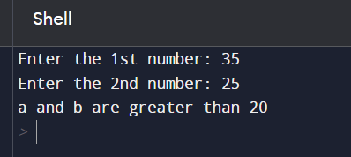

2. Write a program to apply Logical OR operator on two operands.

Ans –

a = int(input("Enter the 1st number: "))

b = int(input("Enter the 2nd number: "))

if a > 20 or b > 20:

print("Any of them is greater than 20")

else:

print("No one is greater than 20")

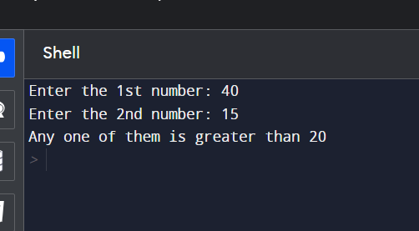

3. Write a program to apply Logical NOT operator on an operand.

Ans –

a = 20

if not a:

print("Bool value of a is True")

if not(a % 3==0 or a%5==0):

print("20 is not divisible by either 5 or 6")

else:

print("20 is divisible by either 5 or 6")

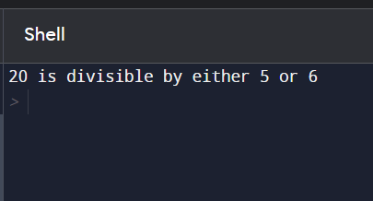

4. Write a program to perform Bitwise AND operation on a = 15 and b =

17.

Ans –

a = 15

b = 17

result = a & b

print("Result of a & b :", result)

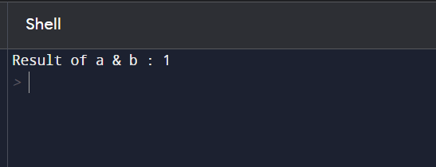

5. Write a program to perform Bitwise OR operation on a = 15 and b = 17.

Ans -

a = 15

b = 17

result = a | b

print("Result of a | b :", result)

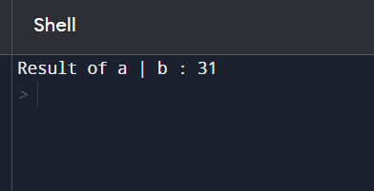

6. Write a program to perform Bitwise XOR operation on a = 15 and b =

17.

Ans –

a = 15

b = 17

result = a ^ b

print("Result of a ^ b :", result)

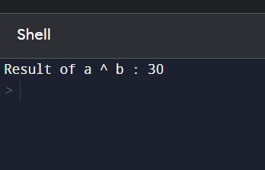

7. Write a program to perform Bitwise negation operation on a = 15.

Ans –

a = 15

print ("The Bitwise Negative is : ", ~a)

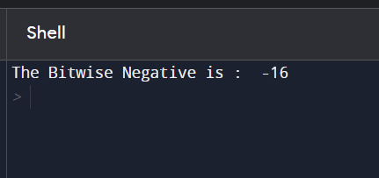

8. Write a program to Swap the Contents of two Numbers using Bitwise

XOR Operation.

Ans –

a = int(input("Enter value of a = "))

b = int(input("Enter value of b = "))

a = a ^ b

b = a ^ b

a = a ^ b

print("The Result After Swapping given two Numbers is:")

print("First Number = ", a)

print("Second Number = ", b)

